**Lung Cancer Detection Using Deep CNN**

**Project Report**

**Submitted by:**

B.Balamurali

R.Elavarasan

M.Elavarasan

M.Dineshwaran

**Abstract:**

Lung cancer is one of the most killer diseases in the developing countries and the detection of the cancer at the early stage is a challenge. Analysis and cure of lung malignancy have been one of the greatest difficulties faced by humans over the most recent couple of decades. Early identification of tumor would facilitate in sparing a huge number of lives over the globe consistently. This paper presents an approach which utilizes a Convolutional Neural Network (CNN) to classify the tumors found in lung as malignant or benign.

**1.INTRODUCTION:**

Lung cancer is of disease of abnormal cells multiplying and growing into a tumor. Cancer cells can be carried away from the lungs in blood, or lymph fluid that surrounds lung tissue. Lymph flows through lymphatic vessels, which drain into lymph nodes located in the lungs and in the center of the chest. Lung cancer often spreads toward the center of the chest because the natural flow of lymph out of the lung is towards the center of the chest.

**1.1 Overview:**

Lung cancer is one of the most dreadful diseases in the developing countries and its mortality rate is 19.4% . Early detection of lung tumor is done by using many imaging techniques such as Computed Tomography (CT), Sputum Cytology, Chest X-ray and Magnetic Resonance Imaging (MRI). Detection means classifying tumor two classes (i)non-cancerous tumor (benign) and (ii)cancerous tumor (malignant).

**1.2 Purpose**:

This lung cancer detection based on chest CT images using CNN. In the first stage, lung regions are extracted from CT image and in that region each slices are segmented to get tumors. The segmented tumor regions are used to train CNN architecture. Then, CNN is used to test the patient images.

**2.Literature Survey:**

**2.1 Exiting Problem:**

The main objective of this study is to detect whether the tumor present in a patient’s lung is malignant or benign. the trained system will able to detect the cancerous presence in lung CT image.

**2.2 Proposed Solution:**

First module is optimization model from which the maxima and minima pixel values are selected and is gives to next module. Second module is similarity measures from where the pixel similarity calculated based on location or color. Third module is computational complexity from which data and time complexity measured. Fourth one is the application to collection of images in which we not only taking single image segmentation, our method implements to multiple images. Fifth module is deep learning neural network(DLNN) which provides complete tuning of image and predicting the lungs affected or not. .In this module training the image with labeled data and un labeled data because of Deep learning could satisfies to both supervised segmentation and un-supervised segmentation. Last module is the performance evaluation from this module CPU performance time for running each image and accuracy calculated based on PSNR.

.

**3.Theoritical Analaysis:**

**3.1 Block Diagram:**



**3.2 Hardware/Software designing:**

For hardware we would need CT scan in which is given as input to the web page.

For software we would need a compatible operating system for python, java script and

HTML.

Software needed are:

1) Tensorflow

2) OpenCV

3) Keras

4) Flask

**4.Experimental Investigation:**

A convolution layer extracts the features of the input images by convolution and outputs the feature maps. It is composed of a series of fixed size filters, known as convolution kernels, which are used to perform convolution operations on image data to produce the feature maps.

 

**5.Flow Chart:**





**6.Result:**

We got an accuracy of 0.86 which is good measure for a ConvolutionNeural Network. The Model predicts the lungs affected or not with good efficiency.

**7.Advantages&Disadvantages:**

Advantages:

(a) Early detection of cancer greatly increases the chances for successful treatment.

(b) With the use of this treatment is often simpler and more likely to be effective.

(c)The proposed systems are more efficient and give the better result.

(d)Provides better image quality and accuracy.

Disadvantages:

(a) The input image must have clarity to predict the correct output.

(b) High computational cost.

**8.Application:**

It is widely used in many medical areas for early detection of cancer .so the the proper treatment will be provided to the patient.

It consists of few stages. The first stage starts with taking a collection of CT images (normal and abnormal) from the available database from IMBA home.

**9.Conclusion:**

A convolutional neural network based system was implemented to detect the malignancy tissues present in the input lung CT image. Lung image with different shape, size of the cancerous tissues has been fed at the input for training the system. It was used to detect the cancer in the lungs.

**10.Future scope:**

Lung Cancer Detection using convolutional neural network minimizes the time of predicting the lungs is affected by cancer or not.

**11.Bibliography:**

Proposed Idea:

https://www.researchgate.net/publication/265998089_Lung_Cancer_Detection_Using_Image_Processing_Techniques

**12.Appendix:**

**12.1 Dataset:**

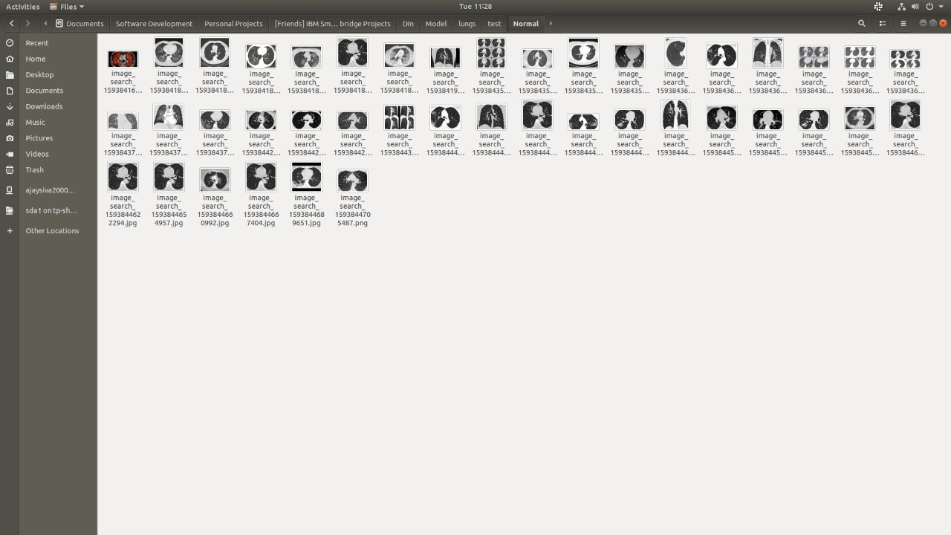

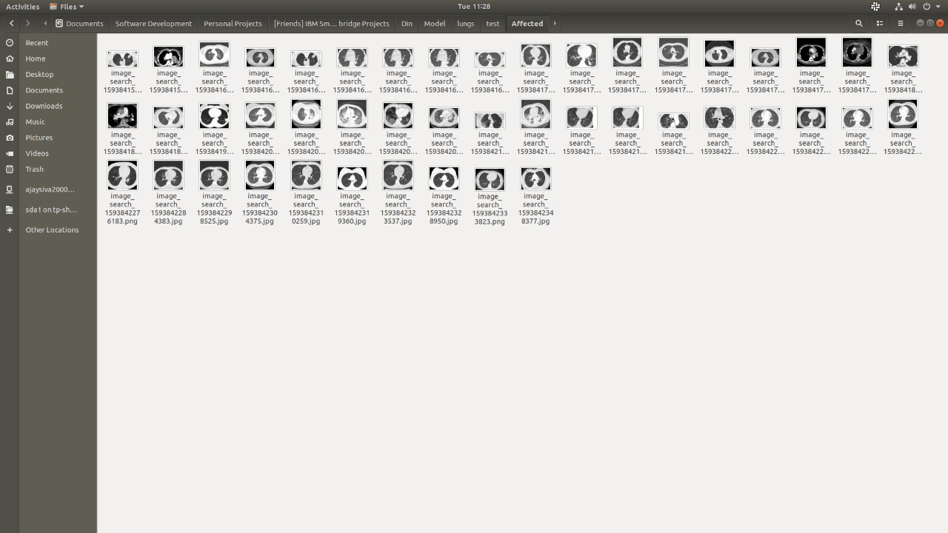

**12.2 Model training:**

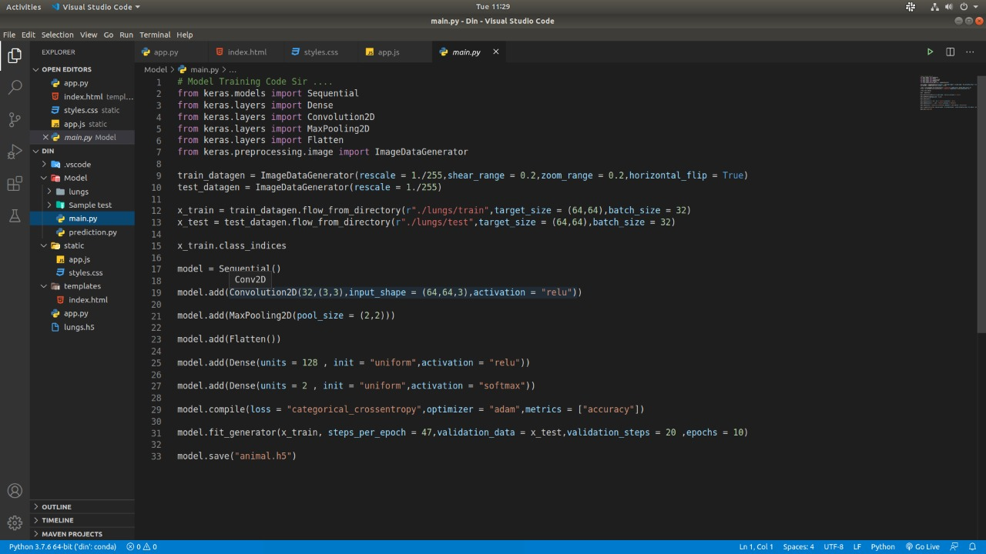

**12.3 Flask:** 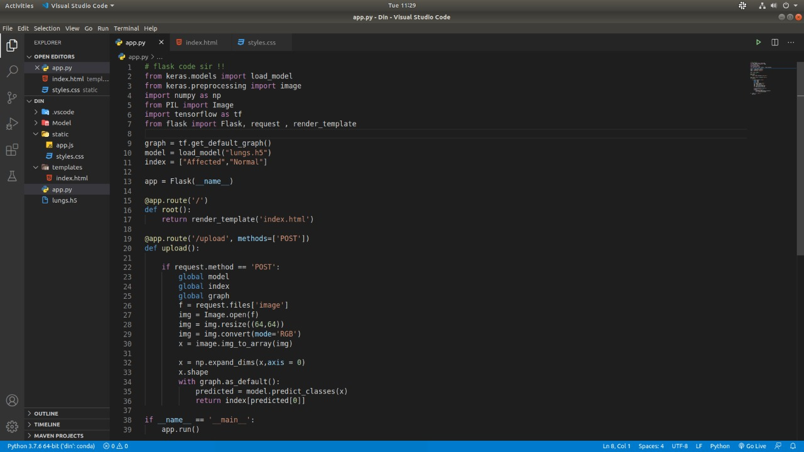

**12.4 Output:**

